**Database Schema:**

The Student Exchange database schema consists of 4 tables, shown in the ERD. These tables are: CART, CATEGORY, LISTING, USERS. This schema is placed in the group4 database.

**The name(s) of your database(s) implemented with passwords:**

The Student Exchange utilizes a single database. The database name is: group4 & password is: studentexchange

**How the tables are implemented, i.e, show your SQL CREATE queries:**

CREATE TABLE USERS

(

studentID INT AUTO_INCREMENT,

fName CHAR(30) NOT NULL,

mName CHAR(30),

lName CHAR(30) NOT NULL,

address VARCHAR(30) NOT NULL,

cCard INT(16),

PRIMARY KEY (studentID)

);

CREATE TABLE CART

(

studentID INT NOT NULL,

itemID INT NOT NULL

);

CREATE TABLE LISTING

(

itemID INT AUTO_INCREMENT NOT NULL,

sellerID INT NOT NULL,

category VARCHAR(30) NOT NULL,

itemName VARCHAR(30) NOT NULL,

itemDescription VARCHAR(255),

buyersID INT NOT NULL,

postDate DATE,

salesDate DATE,

PRIMARY KEY (itemID, postDate)

);

CREATE TABLE CATEGORY

(

catType VARCHAR(100),

PRIMARY KEY (catType)

);

ALTER TABLE CART

ADD FOREIGN KEY FK_CART1(studentID)

REFERENCES USERS(studentID);

ALTER TABLE CART

ADD FOREIGN KEY FK_CART2(itemID)

REFERENCES LISTING(itemID);

ALTER TABLE LISTING

ADD FOREIGN KEY FK_LISTING1(category)

REFERENCES CATEGORY(catType);

ALTER TABLE LISTING

ADD FOREIGN KEY FK_LISTING2(buyersID)

REFERENCES USER(studentID);

ALTER TABLE LISTING

ADD FOREIGN KEY FK_LISTING3(sellerID)

REFERENCES USER(studentID);

ALTER TABLE USERS

ADD STATE CHAR(2) AFTER ADDRESS;

ALTER TABLE USERS

ADD CITY CHAR(30) AFTER STATE;

ALTER TABLE USERS

ADD ZIPCODE INT(5) AFTER CITY;

**Show the content of the tables after populating them with some sample data:**

LISTING TABLE**:**



CATEGORY TABLE:

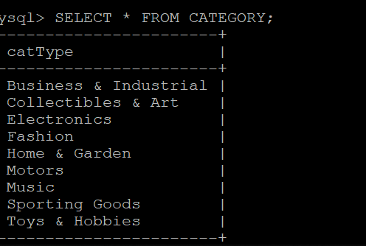

USERS TABLE:

